Tarefa 01  
  
1-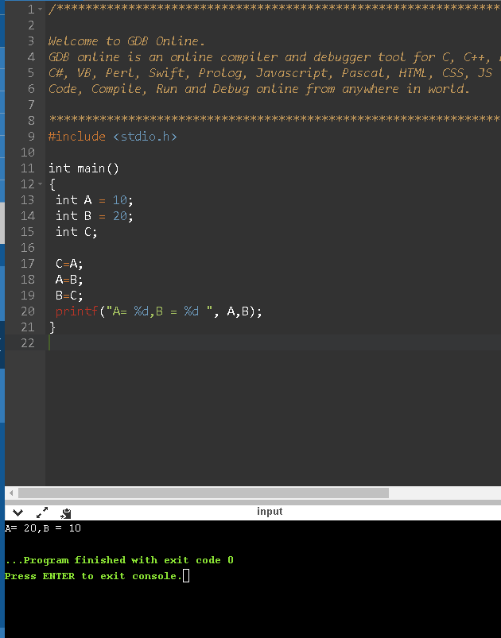  
  
2-

A-

#include <stdio.h>

Int main ()

Int A = 10, Int B = 20;

Printf(“Valor de B : %d “, b);

B=5

Printf(“O valor de A e de B é: %d e %d”, A,B);

B-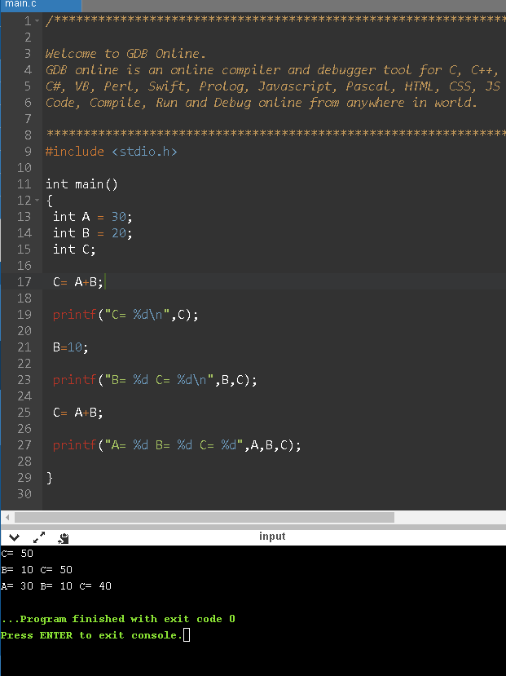  
  
  
  
  
  
C-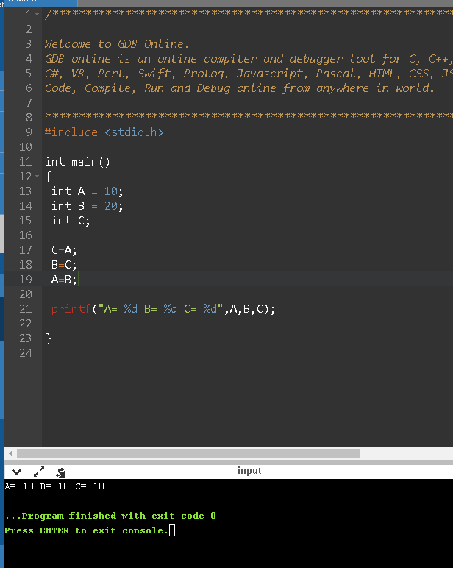  
  
  
  
  
  
  
  
  
D-

#include <stdio.h>

int main()

{

int A = 10;

int B;

int C;

B=A+1;

A=B+1;

printf("A=%d\n",A);

A=B+1;

printf("A= %d B = %d", A,B);

}  
  
  
  
  
E-  
#include <stdio.h>

int main()

{

int A = 10;

int B = 5;

int C;

C= B + A;

printf("A=%d\n",A);

A = 10;

B = 20;

printf("A= %d B = %d C = %d", A,B,C);

}  
  
  
  
  
  
  
  
  
f-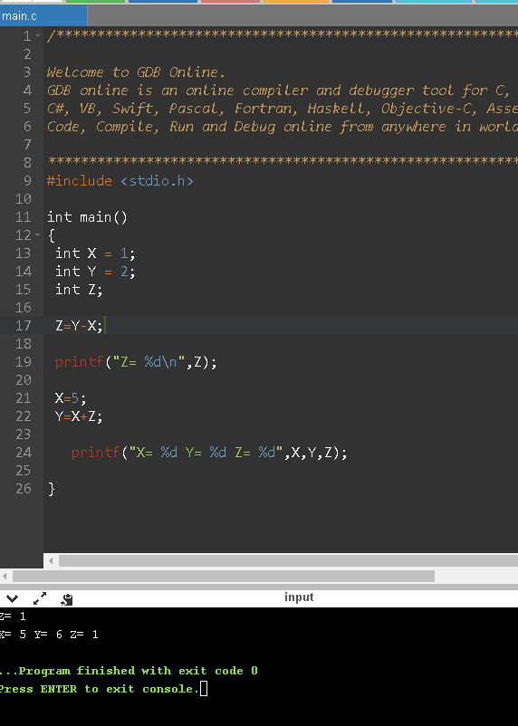

3-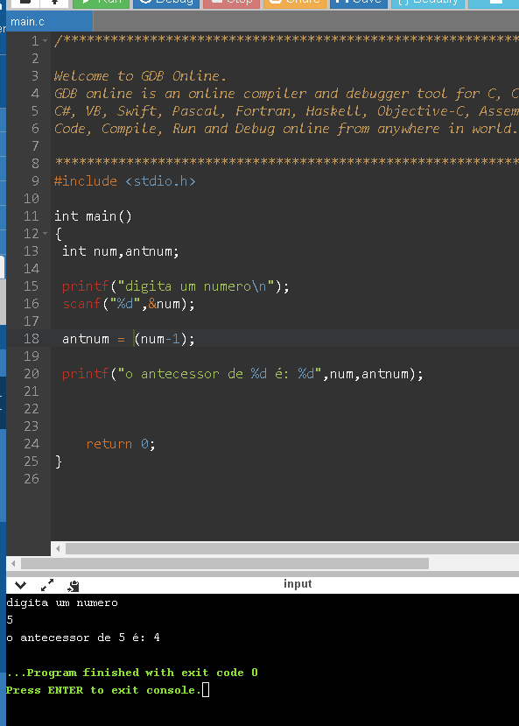  
  
4-